Chapter 1
Introduction
An innovative and useful concept of Generating Electricity from a Speed breakeris our step to improve the situation of electricity .First of all what is electricity means to us? Electricity is the form of energy. It is the flow of electrical Power. Electricity is a basic part of nature and it is one of our most widely used forms of energy. We get electricity, which is a secondary energy source, from the conversion of other sources of energy, like coal, natural gas, oil, nuclear power and other natural sources, which are called primary sources. Many cities and towns were built alongside waterfalls that turned water wheels to perform work. Before electricity generation began slightly over 100 years ago, houses were lit with kerosene lamps, food was cooled in iceboxes, and rooms were warmed by wood-burning or coal-burning stoves. Direct current (DC) electricity had been used in arc lights for outdoor lighting. In the late-1800s, Nikola Tesla pioneered the generation, transmission, and use of alternating current (AC) electricity, which can be transmitted over much greater distances than direct current. Tesla's inventions used electricity to bring indoor lighting to our homes and to power industrial machines.
Electricity generation was first developed in the 1800's using Faradays dynamo generator. Almost 200 years later we are still using the same basic principles to generate electricity, only on a much larger scale. Now we are throwing some light on the very new and innovative concept i.e. GENERATING ELECTRICITY FROM A SPEED BREAKER. Producing electricity from a speed breaker is a new concept that is undergoing research. India's installed capacity is nearly 20 per cent of China's capacity though both countries have billion plus people. There is roughly 12 per cent power deficit in the peak hours. Tariffs are set by the state governments so power firms are not allowed to pass on rising fuel costs to consumers. Banks are burdened with loans to loss-making state-run electricity distribution firms and are unwilling to lend to new projects that do not have assured fuel supply. India has nearly 10 per cent of the world's coal reserves but lack of environmental clearances and other disputes have hindered production. Shortage of domestic supply has resulted in costlier imports.
Coal fired power plants account for more than half of India's power generation.From 2001 – 2004, India’s oil demand has been growing by 2.68% but it will grow by 6.33% from 2003 – 2004 (projection from Qtr 1, IEA, 2004)
- Oil and gas represent 38% of India’s energy consumption (IBEF, 2004)
- By 2010, India will be the fourth largest consumer of oil and gas in the world (IBEF, 2004)
- (In fact, China’s demand growth is even more - disastrously - rapid)
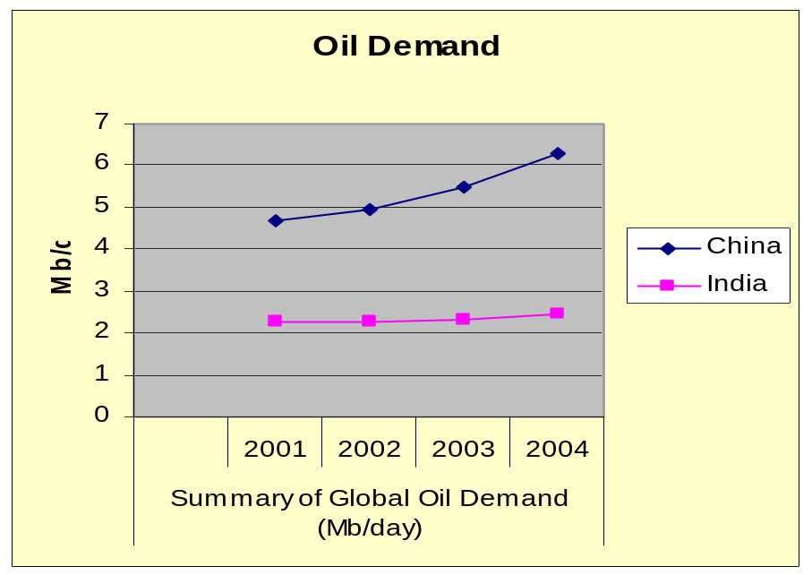

Fig. 1.1 Summary of Global Oil Demand
Likewise the Russia-Ukraine gas dispute and the Russia-Belarus energy dispute have been mostly resolved before entering a prolonged crisis stage. Market failure is possible when monopoly manipulation of markets occurs. A crisis can develop due to industrial actions like union organized strikes and government embargoes. The cause may be ageing over-consumption, infrastructure and sometimes bottlenecks at oil refineries and port facilities restrict fuel supply. An emergency may emerge during unusually cold winters. EMERGING SHORTAGES Crisis that currently exist include; • Oil price increases since 2003 - Cause: increasing demand from the U.S and China, the falling state of the U.S. dollar, and stagnation of production due to the U.S. occupation of Iraq. Iraq is #3 in the world (besides Saudi Arabia and Iran) for its oil reserves. However some observers have stated the global oil production peak occurred in December 2005. If this is correct it is also to blame. • 2008 Central Asia energy crisis, caused by abnormally cold temperatures and low water levels in an area dependent on hydroelectric power
The availability of regular conventional fossil fuels will be the main sources for power generation, but there is a fear that they will get exhausted eventually by the next few decades. Therefore, we have to investigate some approximate, alternative, new sources for the power generation, which is not depleted by the very few years. Another major problem, which is becoming the exiting topic for today is the pollution. It suffers all the living organisms of all kinds as on the land, in aqua and in air. Power stations and automobiles are the major pollution producing places. Therefore, we have to investigate other types of renewable sources, which produce electricity without using any commercial fossil fuels, which is not producing any harmful products. There are already existing such systems using renewable energy such as solar wind), OTEC (ocean thermal energy conversions) etc…for power generation. The latest technology which is used to generate the power by such renewable energy is the” POWER HUMP”
The number of vehicles on road is increasing rapidly and if we convert some of the Potential energy of these vehicle into the rotational motion of generator then we can produce considerable amount of electricity, this is the main concept of this project. At present we are facing shortage of electricity. Electricity can be generated using speed breakers, strange, isn't it? The benefits from this idea will be to generate electricity for the streetlights, hoardings and then for other use.Generally when vehicle is in motion it produces various forms of energy like, due to friction between vehicle’s wheel and road i.e. rough surface HEAT Energy is produced, also when vehicle traveling at high speed strikes the wind then also heat energy is produced which is always lost in environment and of which we can’t make use of….OR directly we can say that all this energy that we can’t make use of is just the WASTAGE OF ENERGY that is abundantly available around us. In this project we are just trying to make use of such energy in order to generate an ELECTRICAL ENERGY. This project will work on the principle of “POTENTIAL ENERGY TO ELECTRICAL ENERGY CONVERSION” Potential energy can be thought of as energy stored within a physical system
Chapter 2
Ways to Produce watts
2.1 Electricity generating arm-band

Fig. 2.1 Arm Band
Location: Glastonbury, England
Owner: Orange Telecom
Concept: A mobile phone charger is powered by dance energy. The kinetic movement of a system of weighs and magnets, which move as you groove, powers the charger. It weighs just 180 grams and can be strapped on the dancer’s bicep. The energy generated while dancing can be fed into your cell phones when the batteries run dry.

2.2 Convert work out sweat into electricity

Fig. 2.2 Energy conversion from sweat in a gym
Location: University of Oregon, US
Technology: ReRev
Concept: The energy from this power generating gym is converted from DC to AC before being transferred into the grid. The output is considerably small; a person pedaling 30 minutes would generate energy to run a laptop for approximately an hour. Hence using this concept energy lost by people in gyms and aerobics daily can be efficiently used to light up the gym as well as run few appliances like laptop, radios .etc.

2.3 Generate electricity while washing your car
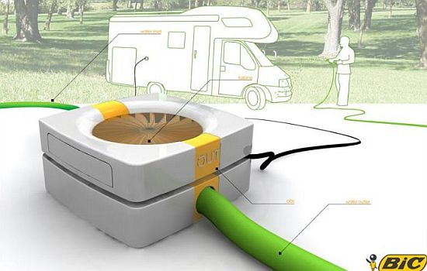
Fig. 2.3 Electricity generation while washing car
Location: USA
Designer: GregoireVandenbussche
Concept: You can recharge your electric car batteries while washing them, using nothing other than the energy of water in the hosepipe, eventually reducing your electricity bills.
The device envisioned by Vandenbussche, POWA Water Generator, is a small turbine that is placed in between the hosepipe. As the water rushes through the pipe it turns, the blades of the small turbine that then generate electricity that can directly be fed into the car.We need to wash our cars regularly to keep them shiny and clean. However, if we could produce electricity while washing our cars, wouldn’t that be an additional bonus for our labour?

2.4 Charge your iPhone while playing golf
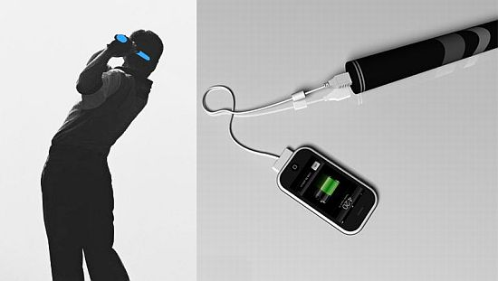
Fig. 2.4 iPhone Charger
Location: Japan
Designer: Mac Funamizu
Concept: The gadget designed by Mac Funamizu harnesses the kinetic energy the user generates, when the grip is swung a certain number of times, that can be later used to charge mobile phones and other gadgets for a couple of hours. The device only has the handgrip and not the actual club, thereby checking the user from stroking a golf ball with this. It not only protects amateur golfers from hurting themselves and others, but also charges their iPhones and other gadgets. So, all you amateur golfers out there, go out to buy this golf kit. It is time to do constructive.

2.5 Roll Kinetic Charger to juice up your batteries
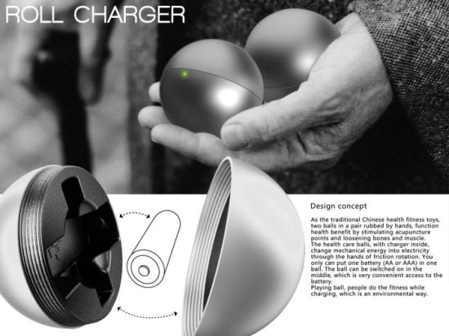
Fig. 2.5 Roll Kinetic Charger
Location: China
Designer: Jiang Qian
Concept: Roll Charger consists of two balls that can be split into two. AA or AAA batteries they are charged by placing them inside each ball. Electricity is generated when the balls are rotated in, eventually charging the batteries inside. They can power remotes or other devices. A LED in the device helps the user to know whether the charger is functioning properly or not and also tells when the battery is fully charged.

2.6 Convert Sound Energy into electricity
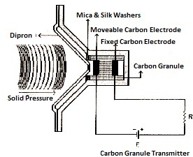
Fig. 2.6 Carbon Granule Transmitter
Location: University of Utah, USA
Designer: Physicist OrestSymko and his students
Concept: Converting sound into electricity works on a simple mechanism. If heat is applied to any enclosed area, the air inside it expands increasing the pressure inside. This pressurized air, then moves through a filter or opening on one side, producing a simple clear sound at a standard frequency. That is the basic idea behind the system. Focused and directed frequency makes it easier to extract energy. The sound waves are then converted in to electricity by squeezing them thorough “piezoelectric” devices.

Chapter 3
Generation of Electricity through Speed breakers
Electricity can be generated with the help of speed breaker by making gear arrangement and using electronics gadgets, thus a huge amount of electricity can be generated saving lot of money.
3.1 Types of Mechanisms
We can develop electricity from speed breakers by using 3 Mechanisms basically
They are as follows:
1) Roller mechanism
2) Crank-shaft mechanism
3) Rack-pinion mechanism
3.1.1 Roller Mechanism

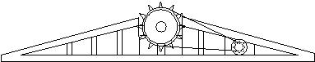
Fig. 3.1 Side view of roller mechanism
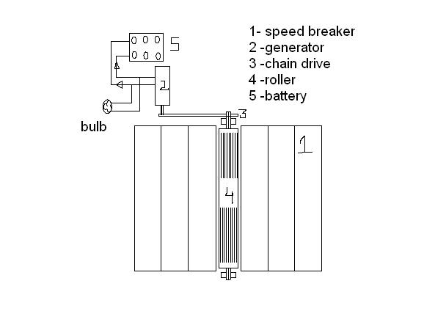
Fig. 3.2 Top View of Roller Mechanism
In this Mechanism, a roller is fitted in between a speed breaker and some kind of a grip is provided on the speed breaker so that when a vehicle passes over speed breaker it rotates the roller. This movement of roller is used to rotate the shaft of D.C. generator by the help of chain drive which is there to provide different speed ratios. As the shaft of D.C. generator rotates, it produces electricity. This electricity is stored in a battery. Then the output of the battery is used to lighten the street lamps on the road. Now during daytime we don’t need electricity for lightening the street lamps so we are using a control switch which is manually operated .The control switch is connected by wire to the output of the battery. The control switch has ON/OFF mechanism which allows the current to flow when needed.

Disadvantages:
- Maintenance will be very difficult
- Might cause collision

3.1.2 Crankshaft mechanism
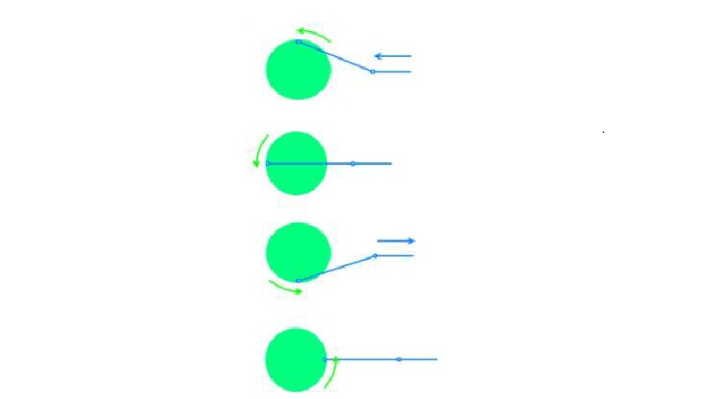
Fig. 3.3 Crankshaft Mechanism
The crankshaft is a mechanism that transforms rotary movement into linear movement, or vice versa. For example, the motion of the pistons in the engine of a car is linear (they go up and down). But the motion of the wheels has to be rotary. So, engineers put a crankshaft between the engine and the transmission to the wheels. The pistons of the engine move the crankshaft and the movement becomes rotary. Then the rotary movement goes past the clutch and the gear box all the way to the wheels.
Disadvantages
- Crank-shafts are required to be mounted on bearings which creates balancing problem.
- Mechanical vibrations which in turn damage the bearings.
- As bearings are of sliding type, any occurrence of variable load( which is bit obvious in case of vehicles) leads to balancing problem

3.1.3 Rack-pinion mechanism
While moving, the vehicles possess some Potential Energy due to its weight and it is being wasted. This kinetic energy can be utilized to produce power by using a special arrangement called POWER HUMP. It is an Electro-Mechanical unit. It utilizes both mechanical technologies and electrical techniques for the power generation and its storage. POWER HUMP is a dome like device likely to be speed breaker. Whenever the vehicle is allowed to pass over the dome it gets pressed downwards then the springs are attached to the dome and are compressed and the rack which is attached to the bottom of the dome moves downward in reciprocating motion. Since the rack has teeth connected to gears, there exists conversion of reciprocating motion of rack into rotary motion of gears but the two gears rotate in opposite direction.. So that the shafts will rotate with certain R.P.M. these shafts are connected through a set of gears to the dynamos, which converts the mechanical energy into electrical energy. The conversion will be proportional to traffic density.
The electrical output can be improved by arranging these POWER HUMPS in series. This generated power can be amplified and stored by using different electrical devices
Advantages
- Rack-Pinion assembly gives good mounting convenience
- Maximum gear losses– 3 to 5%
- Approximate Efficiency– 95%

Since this mechanism is convenient to produce ample amount of energy with maximum efficiency, we have chosen this method for our project with a very simple and effective design for generating electricity using a generator.
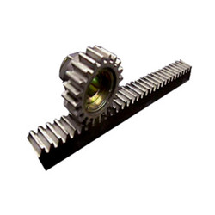
Fig. 3.4 Rack-Pinion Assembly
Chapter 4
Methodology
- Literary survey
- Basic Outline of system
- Procurement of parts
- Fabrication and assembly
- Testing and experimentation

  - Literary survey
- The Burger King on U.S. Highway, Customers pull in and out all day, and at least 100,000 cars visit the drive-thru each year. And a newly installed, mechanized speed bump(video) will both help them slow down and harvest some of that coasting energy.
The weight of a car is used to throw a lever, explains Gerard Lynch, the engineer behind the MotionPower system developed for New Energy Technologies, a Maryland-based company. "The instantaneous power is 2,000 watts at five miles-per-hour, but it's instantaneous which means some form of storage will be required.

Fig. 4.1 Speed Bump
- ASWATHAMAN.V,ELECTRONICS AND COMMUNICATIONENGINEERING SONA COLLEGE OF TECHNOLOGY, SALEM, INDIA
PRIYADHARSHINI.M, ELECTRONICS AND COMMUNICATIONENGINEERING
SONA COLLEGE OF TECHNOLOGY,SALEM, INDIA.

This paper attempts to show how energy can be tapped and used at a commonly used system- the road speed breakers. The number of vehicles passing over the speed breaker in roads is increasing day by day. A large amount of energy is wasted at the speed breakers through the dissipation of heat and also through friction, every time a vehicle passes over it. There is great possibility of tapping this energy and generating power by making the speed-breaker as a power generation unit. The generated power can be used for the lamps, near the speed breakers. The utilization of energy is an indication of the growth of a nation. For example, the per capita energy consumption in USA is 9000 KWh (Kilo Watt hour) per year, whereas the consumption in India is 1200 KWh (Kilo Watt hour). One might conclude that to be materially rich and prosperous, a human being needs to consume more and more energy. A recent survey on the energy consumption in India had published a pathetic report that 85,000 villages in India do
not still have electricity. Supply of power in most part of the country is poor. Hence more research and development and commercialization of technologies are needed in this field. India, unlike the top developed countries has very poor roads. Talking about a particular road itself includes a number of speed breakers. By just placing a unit like the “Power Generation Unit from Speed Breakers”, so much of energy can be tapped. This energy can be used for the lights
on the either sides of the roads and thus much power that is consumed by these lights can be utilized to send power to these villages.
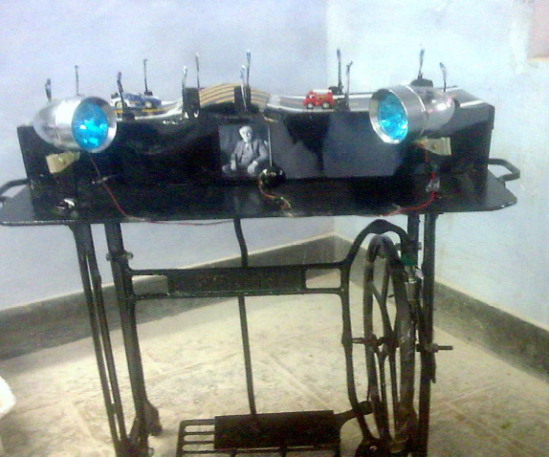
3)Journal of Engineering Research and Studies.PRODUCE ELECTRICITY BY THE USE OF SPEED BREAKERS Shakun Srivastava , Ankit asthana, Department of mechanical engineering, Kanpur institute of technology, Kanpur
Fig. 4.2 Speed Breaker model

The rotor (rotating shaft) is directly connected to the prime mover and rotates as the prime mover turns. The rotor contains a magnet that, when turned, produces a moving or rotating magnetic field. The rotor is surrounded by a stationary casing called the stator, which contains the wound copper coils or windings. When the moving magnetic field passes by these windings, electricity is produced in them. By controlling the speed at which the rotor is turned, a steady flow of electricity is produced in the windings. These windings are connected to the electricity network via transmission lines. IIT Guwahati has evaluated the machine and recommended it to the Assam ministry of power for large scale funding. IIT design department says it is a ‘very viable proposition’ to harness thousands of megawatts of electricity untapped across the country every day. A vehicle weighing 1,000 kg going up a height of 10 cm on such a rumble strip produces approximately 0.98 kilowatt power. So one such speed-breaker on a busy highway, where about 100vehicles pass every minute, about one kilo watt of electricity can be produced every single minute. The figure will be huge at the end of the day. A storage module like an inverter will have to be fitted to each such rumble strip to store this electricity. The cost of electricity generation and storage per megawatt from speed-breakers will be nearly Rs 1 crore as opposed to about Rs 8 crores in thermal or hydro power stations.
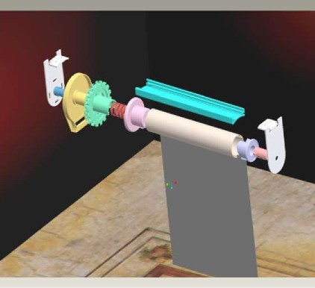
Fig. 4.3 Power Hump Project
4.2Basic Outline of system

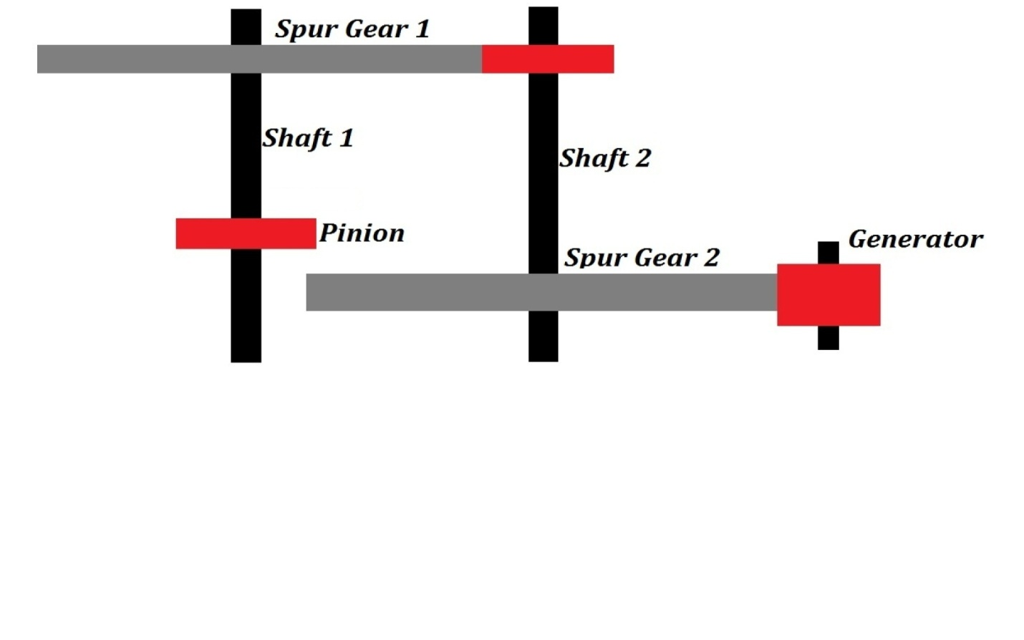
Fig. 4.4 Basic Outline of system

The project is concerned with generation of electricity from speed breakers-like set up. The load acted upon the speed breaker - setup is there by transmitted to rack and pinion arrangements. Here the reciprocating motion of the speed-breaker is converted into rotary motion using the rack and pinion arrangement. The axis of the pinion is coupled with a gear. This gear is meshed a pinion. As the power is transmitted from the gear to the pinion, the speed that is available at the gear is relatively multiplied at the rotation of the pinion.
The axis of the pinion is coupled to a gear arrangement. Here we have two gears with different diameters. The gear (larger dimension) is coupled to the axis of the pinion. Hence the speed that has been multiplied at the smaller sprocket wheel is passed on to this gear of larger dimension. The pinion is meshed to the gear. So as the gear rotates at the multiplied speed of the pinion, the pinion following the gear still multiplies the speed to more intensity. Hence, although the speed due to the rotary motion achieved at the first gear is less, as the power is transmitted to gears the speed is multiplied to a higher speed. This speed is sufficient to rotate the rotor of a generator.
The rotor which rotates within a static magnetic stator cuts the magnetic flux surrounding it, thus producing the electric motive force (emf). This generated emf is then sent to a bridge rectifier, where the generated AC current is converted to DC. This regulated emf is now sent to the lead-acid battery

4.3 Procurement of parts
4.3.1 Gears
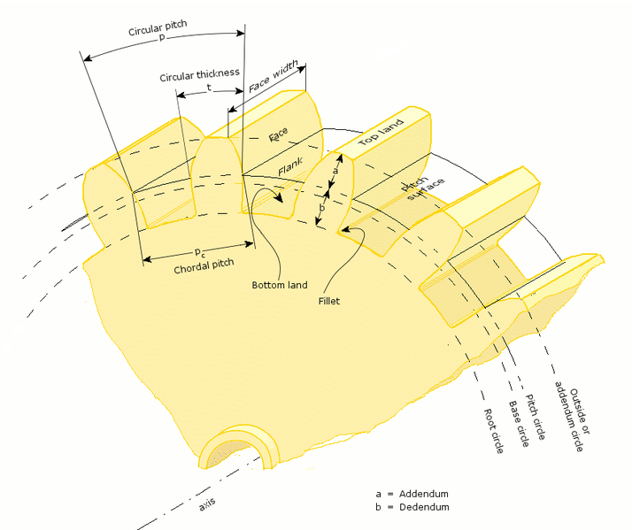
Fig. 4.5 Parts of a Gear
A gear is a rotating machine part having cut teeth, or cogs, which mesh with another toothed part in order to transmit torque. Two or more gears working in tandem are called a transmission and can produce a mechanical advantage through a gear ratio and thus may be considered a simple machine. Geared devices can change the speed, torque, and direction of a power source. The most common situation is for a gear to mesh with another gear, however a gear can also mesh a non-rotating toothed part, called a rack, thereby producing translation instead of rotation.
The gears in a transmission are analogous to the wheels in a pulley. An advantage of gears is that the teeth of a gear prevent slipping.
When two gears of unequal number of teeth are combined a mechanical advantage is produced, with both the rotational speeds and the torques of the two gears differing in a simple relationship.
In transmissions which offer multiple gear ratios, such as bicycles and cars, the term gear, as in first gear, refers to a gear ratio rather than an actual physical gear. The term is used to describe similar devices even when gear ratio is continuous rather than discrete, or when the device does not actually contain any gears, as in a continuously variable transmission.
The earliest known reference to gears was circa A.D. 50 by Hero of Alexandria, but they can be traced back to the Greek mechanics of the Alexandrian school in the 3rd century B.C. and were greatly developed by the Greek polymath Archimedes (287–212 B.C.).The Antikythera mechanism is an example of a very early and intricate geared device, designed to calculate astronomical positions. Its time of construction is now estimated between 150 and 100 BC.
General Nomenclature of Gears
Number of teeth, N
How many teeth a gear has, an integer. In the case of worms, it is the number of thread starts that the worm has.
Gear, wheel
The larger of two interacting gears or a gear on its own.
Pinion
The smaller of two interacting gears.
Path of contact
Path followed by the point of contact between two meshing gear teeth.
Line of action, pressure line
Line along which the force between two meshing gear teeth is directed. It has the same direction as the force vector. In general, the line of action changes from moment to moment during the period of engagement of a pair of teeth. For involute gears, however, the tooth-to-tooth force is always directed along the same line—that is, the line of action is constant. This implies that for involute gears the path of contact is also a straight line, coincident with the line of action—as is indeed the case.
Axis
Axis of revolution of the gear; center line of the shaft.
Pitch point, p
Point where the line of action crosses a line joining the two gear axes.
Pitch circle, pitch line
Circle centered on and perpendicular to the axis, and passing through the pitch point. A predefined diametral position on the gear where the circular tooth thickness, pressure angle and helix angles are defined.
Pitch diameter, d
A predefined diametral position on the gear where the circular tooth thickness, pressure angle and helix angles are defined. The standard pitch diameter is a basic dimension and cannot be measured, but is a location where other measurements are made. Its value is based on the number of teeth, the normal module (or normal diametral pitch), and the helix angle.
Module, m
A scaling factor used in metric gears with units in millimeters whose effect is to enlarge the gear tooth size as the module increases and reduce the size as the module decreases. Module can be defined in the normal (m_{n}), the transverse (m_{t}), or the axial planes (m_{a}) depending on the design approach employed and the type of gear being designed. Module is typically an input value into the gear design and is seldom calculated.
Operating pitch diameters
Diameters determined from the number of teeth and the center distance at which gears operate.
Pitch surface
In cylindrical gears, cylinder formed by projecting a pitch circle in the axial direction. More generally, the surface formed by the sum of all the pitch circles as one moves along the axis. For bevel gears it is a cone.

Angle of action
Angle with vertex at the gear center, one leg on the point where mating teeth first make contact, the other leg on the point where they disengage.
Arc of action
Segment of a pitch circle subtended by the angle of action.
Pressure angle,
The complement of the angle between the direction that the teeth exert force on each other, and the line joining the centers of the two gears. For involute gears, the teeth always exert force along the line of action, which, for involute gears, is a straight line; and thus, for involute gears, the pressure angle is constant.
Outside diameter,
Diameter of the gear, measured from the tops of the teeth.
Root diameter
Diameter of the gear, measured at the base of the tooth.
Addendum, a
Radial distance from the pitch surface to the outermost point of the tooth.
Dedendum, b
Radial distance from the depth of the tooth trough to the pitch surface.
Whole depth,
The distance from the top of the tooth to the root; it is equal to addendum plus dedendum or to working depth plus clearance.
Clearance
Distance between the root circle of a gear and the addendum circle of its mate.
Working depth
Depth of engagement of two gears, that is, the sum of their operating addendums.
Circular pitch, p
Distance from one face of a tooth to the corresponding face of an adjacent tooth on the same gear, measured along the pitch circle.

Diametral pitch,
Ratio of the number of teeth to the pitch diameter.Could be measured in teeth per inch or teeth per centimeter.
Base circle
In involute gears, where the tooth profile is the involute of the base circle. The radius of the base circle is somewhat smaller than that of the pitch circle.
Base pitch, normal pitch,
In involute gears, distance from one face of a tooth to the corresponding face of an adjacent tooth on the same gear, measured along the base circle.
Interference
Contact between teeth other than at the intended parts of their surfaces.
Interchangeable set
A set of gears, any of which will mate properly with any other.

Tooth contact nomenclature
Point of contact
Any point at which two tooth profiles touch each other.
Line of contact
A line or curve along which two tooth surfaces are tangent to each other.
Path of action
The locus of successive contact points between a pair of gear teeth, during the phase of engagement. For conjugate gear teeth, the path of action passes through the pitch point. It is the trace of the surface of action in the plane of rotation.
Line of action
The path of action for involute gears. It is the straight line passing through the pitch point and tangent to both base circles.
Surface of action
The imaginary surface in which contact occurs between two engaging tooth surfaces. It is the summation of the paths of action in all sections of the engaging teeth.
Plane of action
The surface of action for involute, parallel axis gears with either spur or helical teeth. It is tangent to the base cylinders.
Zone of action (contact zone)
For involute, parallel-axis gears with either spur or helical teeth, is the rectangular area in the plane of action bounded by the length of action and the effective face width.
Path of contact
The curve on either tooth surface along which theoretical single point contact occurs during the engagement of gears with crowned tooth surfaces or gears that normally engage with only single point contact.
Length of action
The distance on the line of action through which the point of contact moves during the action of the tooth profile.
Arc of action, Q_{t}
The arc of the pitch circle through which a tooth profile moves from the beginning to the end of contact with a mating profile.
Arc of approach, Q_{a}
The arc of the pitch circle through which a tooth profile moves from its beginning of contact until the point of contact arrives at the pitch point.
Arc of recess, Q_{r}
The arc of the pitch circle through which a tooth profile moves from contact at the pitch point until contact ends.
Contact ratio, m_{c}, ε
The number of angular pitches through which a tooth surface rotates from the beginning to the end of contact.In a simple way, it can be defined as a measure of the average number of teeth in contact during the period in which a tooth comes and goes out of contact with the mating gear.

Spur Gears
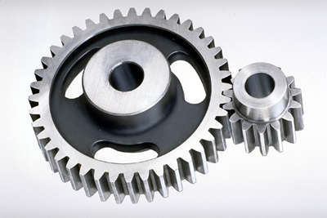
Fig. 4.6 Spur Gears

Spur gears or straight-cut gears are the simplest type of gear. They consist of a cylinder or disk with the teeth projecting radially, and although they are not straight-sided in form, the edge of each tooth is straight and aligned parallel to the axis of rotation. These gears can be meshed together correctly only if they are fitted to parallel shafts
Spur gears are regularly used for speed reduction or increase, torque multiplication, resolution and accuracy enhancement for positioning systems. The teeth run parallel to the gear axis and can only transfer motion between parallel-axis gear sets. Spur gears mate only one tooth at a time, resulting in high stress on the mating teeth and noisy operation.

Bevel Gears
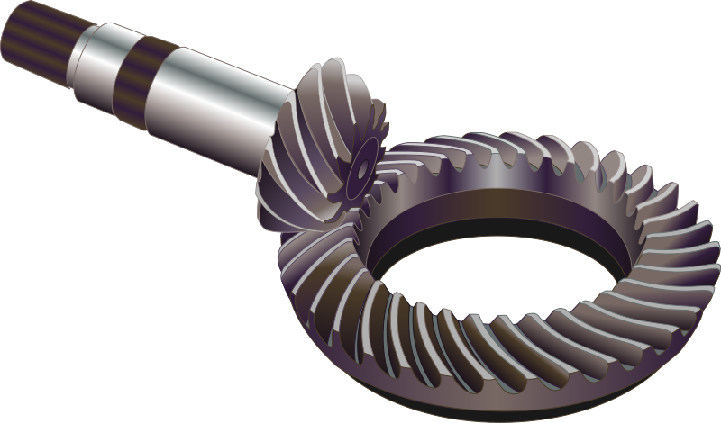Fig. 4.7 Bevel Gears

Bevel gears are gears where the axes of the two shafts intersect and the tooth-bearing faces of the gears themselves are conically shaped. Bevel gears are most often mounted on shafts that are 90 degrees apart, but can be designed to work at other angles as well. The pitch surface of bevel gears is a cone. The most familiar kinds of bevel gears have pitch angles of less than 90 degrees and therefore are cone-shaped. This type of bevel gear is called external because the gear teeth point outward. The pitch surfaces of meshed external bevel gears are coaxial with the gear shafts; the apexes of the two surfaces are at the point of intersection of the shaft axes.
Bevel gears that have pitch angles of greater than ninety degrees have teeth that point inward and are called internal bevel gears.Bevel gears that have pitch angles of exactly 90 degrees have teeth that point outward parallel with the axis and resemble the points on a crown. That's why this type of bevel gear is called a crown gear.

Helical Gears
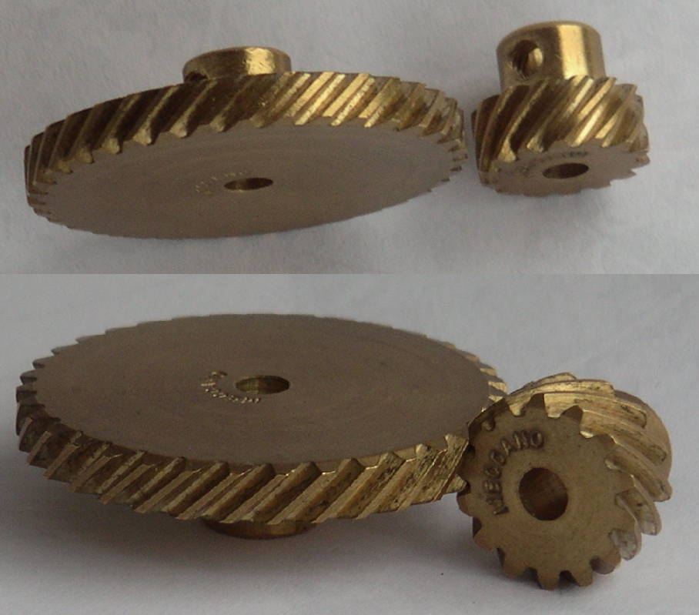
Fig. 4.8 Helical Gears
Helical or "dry fixed" gears offer a refinement over spur gears. The leading edges of the teeth are not parallel to the axis of rotation, but are set at an angle. Since the gear is curved, this angling causes the tooth shape to be a segment of a helix. Helical gears can be meshed in a parallel or crossed orientations. The former refers to when the shafts are parallel to each other; this is the most common orientation. In the latter, the shafts are non-parallel, and in this configuration are sometimes known as "skew gears".
The angled teeth engage more gradually than do spur gear teeth causing them to run more smoothly and quietly With parallel helical gears, each pair of teeth first make contact at a single point at one side of the gear wheel; a moving curve of contact then grows gradually across the tooth face to a maximum then recedes until the teeth break contact at a single point on the opposite side. In spur gears teeth suddenly meet at a line contact across their entire width causing stress and noise. Spur gears make a characteristic whine at high speeds. Whereas spur gears are used for low speed applications and those situations where noise control is not a problem, the use of helical gears is indicated when the application involves high speeds, large power transmission, or where noise abatement is important. The speed is considered to be high when the pitch line velocity exceeds 25 m/s.
A disadvantage of helical gears is a resultant thrust along the axis of the gear, which needs to be accommodated by appropriate thrust bearings, and a greater degree of sliding friction between the meshing teeth, often addressed with additives in the lubricant.
Worm Gears
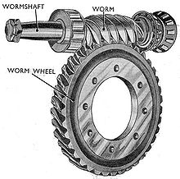Fig. 4.9 Worm Gears
A worm gear is usually meshed with a spur gear or a helical gear, which is called the gear, wheel, or worm wheel.Worm gears can be considered a species of helical gear, but its helix angle is usually somewhat large (close to 90 degrees) and its body is usually fairly long in the axial direction; and it is these attributes which give it screw like qualities. The distinction between a worm and a helical gear is made when at least one tooth persists for a full rotation around the helix. If this occurs, it is a 'worm'; if not, it is a 'helical gear'. A worm may have as few as one tooth. If that tooth persists for several turns around the helix, the worm will appear, superficially, to have more than one tooth, but what one in fact sees is the same tooth reappearing at intervals along the length of the worm. The usual screw nomenclature applies: a one-toothed worm is called single thread or single start; a worm with more than one tooth is called multiple thread or multiple start. The helix angle of a worm is not usually specified. Instead, the lead angle, which is equal to 90 degrees minus the helix angle, is given.
In a worm-and-gear set, the worm can always drive the gear. However, if the gear attempts to drive the worm, it may or may not succeed. Particularly if the lead angle is small, the gear's teeth may simply lock against the worm's teeth, because the force component circumferential to the worm is not sufficient to overcome friction. Worm-and-gear sets that do lock are called self locking, which can be used to advantage, as for instance when it is desired to set the position of a mechanism by turning the worm and then have the mechanism hold that position. An example is the machine head found on some types of stringed instruments.
If the gear in a worm-and-gear set is an ordinary helical gear only a single point of contact will be achieved If medium to high power transmission is desired, the tooth shape of the gear is modified to achieve more intimate contact by making both gears partially envelop each other. This is done by making both concave and joining them at a saddle point; this is called a cone-driveor "Double enveloping"
Worm gears can be right or left-handed following the long established practice for screw threads

4.3.2 GENERATOR
Electric generator is a device that converts mechanical energy to electrical energy. A generator forces electric charge (usually carried by electrons) to flow through an external electrical circuit. It is analogous to a water pump, which causes water to flow (but does not create water). The source of mechanical energy may be a reciprocating or turbine steam engine, water falling through a turbine or waterwheel, an internal combustion engine, a wind turbine, a hand crank, compressed air or any other source of mechanical energy.
The reverse conversion of electrical energy into mechanical energy is done by an electric motor, and motors and generators have many similarities. Many motors can be mechanically driven to generate electricity, and frequently make acceptable generators.
Historical developments
Before the connection between magnetism and electricity was discovered, electrostatic generators were invented that used electrostatic principles. These generated very high voltages and low currents. They operated by using moving electrically charged belts, plates and disks to carry charge to a high potential electrode. The charge was generated using either of two mechanisms:
  - Electrostatic induction
  - The triboelectric effect, where the contact between two insulators leaves them charged.
Because of their inefficiency and the difficulty of insulating machines producing very high voltages, electrostatic generators had low power ratings and were never used for generation of commercially significant quantities of electric power. The Wimshurst machine and Van de Graaff generator are examples of these machines that have survived.
In 1827, Hungarian AnyosJedlik started experimenting with the electromagnetic rotating devices which he called electromagnetic self-rotors. In the prototype of the single-pole electric starter (finished between 1852 and 1854) both the stationary and the revolving parts were electromagnetic. He formulated the concept of the dynamo at least 6 years before Siemens and Wheatstone but didn't patent it as he thought he wasn't the first to realize this. In essence the concept is that instead of permanent magnets, two electromagnets opposite to each other induce the magnetic field around the rotor. It was also the discovery of the principle of self-excitation.
Faraday's disk
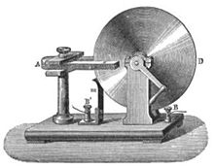
Fig. 4.10 Faraday’s Disk
Faraday disk, the first electric generator. The horseshoe-shaped magnet (A) created a magnetic field through the disk (D). When the disk was turned this induced an electric current radially outward from the centre toward the rim. The current flowed out through the sliding spring contact m, through the external circuit, and back into the centre of the disk through the axle.
This design was inefficient due to self-cancelling counter flows of current in regions not under the influence of the magnetic field. While current was induced directly underneath the magnet, the current would circulate backwards in regions outside the influence of the magnetic field. This counter flow limits the power output to the pickup wires and induces waste heating of the copper disc. Later homo-polar generators would solve this problem by using an array of magnets arranged around the disc perimeter to maintain a steady field effect in one current-flow direction.
Another disadvantage was that the output voltage was very low, due to the single current path through the magnetic flux. Experimenters found that using multiple turns of wire in a coil could produce higher, more useful voltages. Since the output voltage is proportional to the number of turns, generators could be easily designed to produce any desired voltage by varying the number of turns. Wire windings became a basic feature of all subsequent generator designs.
Terminology
The two main parts of a generator or motor can be described in either mechanical or electrical terms.
Mechanical:
- Rotor: The rotating part of an electrical machine
- Stator: The stationary part of an electrical machine
Electrical:
- Armature: The power-producing component of an electrical machine. In a generator, alternator, or dynamo the armature windings generate the electric current. The armature can be on either the rotor or the stator.
- Field: The magnetic field component of an electrical machine. The magnetic field of the dynamo or alternator can be provided by either electromagnets or permanent magnets mounted on either the rotor or the stator.
Because power transferred into the field circuit is much less than in the armature circuit, AC generators nearly always have the field winding on the rotor and the stator as the armature winding. Only a small amount of field current must be transferred to the moving rotor, using slip rings. Direct current machines (dynamos) require a commutator on the rotating shaft to convert thealternating current produced by the armature to direct current, so the armature winding is on the rotor of the machine.

Excitation(Magnetic)
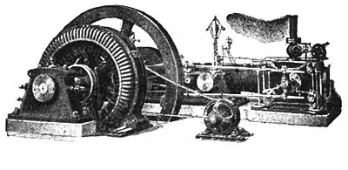
Fig. 4.11 A small early 1900s 75 KVA direct-driven power station AC alternator, with a separate belt-driven exciter generator.

An electric generator or electric motor that uses field coils rather than permanent magnets requires a current to be present in the field coils for the device to be able to work. If the field coils are not powered, the rotor in a generator can spin without producing any usable electrical energy, while the rotor of a motor may not spin at all.
Smaller generators are sometimes self-excited, which means the field coils are powered by the current produced by the generator itself. The field coils are connected in series or parallel with the armature winding. When the generator first starts to turn, the small amount of remanent magnetism present in the iron core provides a magnetic field to get it started, generating a small current in the armature. This flows through the field coils, creating a larger magnetic field which generates a larger armature current. This "bootstrap" process continues until the magnetic field in the core levels off due to saturation and the generator reaches a steady state power output.
Very large power station generators often utilize a separate smaller generator to excite the field coils of the larger. In the event of a severe widespread power outage where islanding of power stations has occurred, the stations may need to perform a black start to excite the fields of their largest generators, in order to restore customer power service.

Faraday's law
Faraday's law is applicable to a closed circuit made of thin wire and states that:
The induced electromotive force (EMF) in any closed circuit is equal to the time rate of change of the magnetic flux through the circuit.
Or alternatively:
The EMF generated is proportional to the rate of change of the magnetic flux.
The law strictly holds only when the closed circuit is an infinitely thin wire; for example, a spinning homopolar generator has a constant magnetically induced EMF, but its magnetic flux does not rise perpetually higher and higher, as it would in a literal interpretation of the statements above.
Electromagnetic induction was discovered independently by Michael Faraday and Joseph Henry in 1831; however, Faraday was the first to publish the results of his experiments.
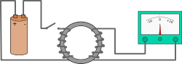
Fig.4.12 Electromagnetic Induction
In Faraday's first experimental demonstration of electromagnetic induction (August 29, 1831), he wrapped two wires around opposite sides of an iron torus (an arrangement similar to a modern transformer). Based on his assessment of recently discovered properties of electromagnets, he expected that when current started to flow in one wire, a sort of wave would travel through the ring and cause some electrical effect on the opposite side. He plugged one wire into a galvanometer, and watched it as he connected the other wire to a battery. Indeed, he saw a transient current (which he called a "wave of electricity") when he connected the wire to the battery, and another when he disconnected it. This induction was due to the change in magnetic flux that occurred when the battery was connected and disconnected. Within two months, Faraday had found several other manifestations of electromagnetic induction. For example, he saw transient currents when he quickly slid a bar magnet in and out of a coil of wires, and he generated a steady (DC) current by rotating a copper disk near a bar magnet with a sliding electrical lead ("Faraday's disk").
Faraday explained electromagnetic induction using a concept he called lines of force. However, scientists at the time widely rejected his theoretical ideas, mainly because they were not formulated mathematically. An exception was Maxwell, who used Faraday's ideas as the basis of his quantitative electromagnetic theory. In Maxwell's papers, the time varying aspect of electromagnetic induction is expressed as a differential equation which Oliver Heaviside referred to as Faraday's law even though it is slightly different in form from the original version of Faraday's law, and does not describe motional EMF. Heaviside's version (see Maxwell–Faraday equation below) is the form recognized today in the group of equations known as Maxwell's equations.
Lenz's law, formulated by Heinrich Lenz in 1834, describes "flux through the circuit", and gives the direction of the induced electromotive force and current resulting from electromagnetic induction (elaborated upon in the examples below).
Faraday's law as two different phenomena
Some physicists have remarked that Faraday's law is a single equation describing two different phenomena: the motional EMF generated by a magnetic force on a moving wire , and the transformer EMF generated by an electric force due to a changing magnetic field (due to the Maxwell–Faraday equation). James Clerk Maxwell drew attention to this fact in his 1861 paper On Physical Lines of Force. In the latter half of part II of that paper, Maxwell gives a separate physical explanation for each of the two phenomena. A reference to these two aspects of electromagnetic induction is made in some modern textbooks
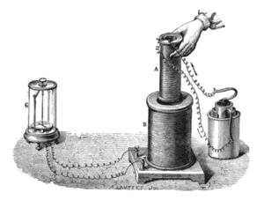
Fig. 4.13 Induction between coils of wire
Faraday's experiment showing induction between coils of wire: The liquid battery (right) provides a current which flows through the small coil (A), creating a magnetic field. When the coils are stationary, no current is induced. But when the small coil is moved in or out of the large coil (B), the magnetic flux through the large coil changes, inducing a current which is detected by the galvanometer (G).
Brushless DC electric motor
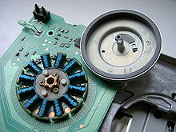
Fig.4.14 Brushless DC electric motor
Motor from a 3.5" floppy disk drive. The coils are copper wire coated with green film insulation. The rotor (upper right) has been removed and turned upside-down. The grey ring just inside its cup is a permanent magnet.
Brushless DC motors (BLDC motors, BL motors) also known as electronically commutated motors (ECMs, EC motors) are synchronous motorswhich are powered by a DC electric source via an integrated inverter, which produces an AC electric signal to drive the motor; additional sensors and electronics control the inverter output.
The motor part of a brushless DC motor is often permanent magnet synchronous motor, but can also be a switched reluctance motor, or induction motor.
BLDC motors may be described as stepper motors, however, the term stepper motor tends to be used for motors that are designed specifically to be operated in a mode where they are frequently stopped with the rotor in a defined angular position; this page describes more general BLDC motor principles, though there is overlap.
Two key performance parameters of brushless DC motors are the Motor constants Kv and Km.
Brushless versus brushed motor
Brushed DC motors have been in commercial use since 1886. BLDC motors, however, have only been commercially possible since 1962.
BLDC motors develop maximum torque when stationary and have linearly decreasing torque with increasing speed. Limitations of brushed DC motors overcome by BLDC motors include lower efficiency and susceptibility of the commutator assembly to mechanical wear and consequent need for servicing, at the cost of potentially less rugged and more complex and expensive control electronics.
A typical BLDC motor has permanent magnets which rotate and a fixed armature, eliminating the problems of connecting current to the moving armature. An electronic controller replaces the brush/commutator assembly of the brushed DC motor, which continually switches the phase to the windings to keep the motor turning. The controller performs similar timed power distribution by using a solid-state circuit rather than the brush/commutator system.
BLDC motors offer several advantages over brushed DC motors, including more torque per weight, more torque per watt (increased efficiency), increased reliability, reduced noise, longer lifetime (no brush and commutator erosion), elimination of ionizing sparks from the commutator, and overall reduction of electromagnetic interference (EMI). With no windings on the rotor, they are not subjected to centrifugal forces, and because the windings are supported by the housing, they can be cooled by conduction, requiring no airflow inside the motor for cooling. This in turn means that the motor's internals can be entirely enclosed and protected from dirt or other foreign matter.
BLDC motor commutation can be implemented in firmware or VHDL. This provides several capabilities not available with brushed DC motors including speed limiting, "micro stepped" operation for slow and/or fine motion control and a holding torque when stationary.
The maximum power that can be applied to a BLDC motor is limited almost exclusively by heat, which can weaken the magnets, or damage insulation. A BLDC motor's main disadvantage is higher cost, which arises from two issues. First, BLDC motors require complex electronic speed controllers (ESCs) to run. Brushed DC motors can be regulated by a comparatively simple controller, such as a rheostat (variable resistor). However, this reduces efficiency because power is wasted in the rheostat. Second, some practical uses have not been well developed in the commercial sector. For example, in the radio control (RC) hobby arena, brushless motors are often hand-wound while brushed motors are usually machine-wound.
BLDC motors are more efficient at converting electricity into mechanical power than brushed DC motors. This improvement is largely due to the absence of electrical and friction losses due to brushes. The enhanced efficiency is greatest in the no-load and low-load region of the motor's performance curve. Under high mechanical loads, BLDC motors and high-quality brushed motors are comparable in efficiency.
Environments and requirements in which manufacturers use brushless-type DC motors include maintenance-free operation, high speeds, and operation where sparking is hazardous (ie explosive environments), or could affect electronically sensitive equipment.
Controller implementations
Because the controller must direct the rotor rotation, the controller requires some means of determining the rotor's orientation/position (relative to the stator coils.) Some designs use Hall effect sensors or a rotary encoder to directly measure the rotor's position. Others measure the back EMF in the undriven coils to infer the rotor position, eliminating the need for separate Hall effect sensors, and therefore are often called sensorless controllers.
A typical controller contains 3 bi-directional outputs (ie frequency controlled three phase output), which are controlled by a logic circuit. Simple controllers employ comparators to determine when the output phase should be advanced, while more advanced controllers employ a microcontroller to manage acceleration, control speed and fine-tune efficiency.
Controllers that sense rotor position based on back-EMF have extra challenges in initiating motion because no back-EMF is produced when the rotor is stationary. This is usually accomplished by beginning rotation from an arbitrary phase, and then skipping to the correct phase if it is found to be wrong. This can cause the motor to run briefly backwards, adding even more complexity to the start up sequence. Other sensorless controllers are capable of measuring winding saturation caused by the position of the magnets to infer the rotor position.
Applications
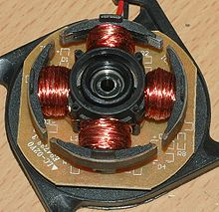
Fig. 4.15 Four poles on the stator of a two-phase BLDC motor
The four poles on the stator of a two-phase BLDC motor. This is part of a computer cooling fan; the rotor has been removed.
BLDC motors fulfill many functions originally performed by brushed DC motors, but cost and control complexity prevents BLDC motors from replacing brushed motors completely in the lowest-cost areas. Nevertheless, BLDC motors have come to dominate many applications, particularly devices such as computer hard drives and CD/DVD players. Small cooling fans in electronic equipment are powered exclusively by BLDC motors. They can be found in cordless power tools where the increased efficiency of the motor leads to longer periods of use before the battery needs to be charged. Low speed, low power BLDC motors are used in direct-drive turntables for gramophone records.
Transport
High power BLDC motors are found in electric vehicles and hybrid vehicles. These motors are essentially AC synchronous motors with permanent magnet rotors.
The Segway Scooter and Vectrix Maxi-Scooter use BLDC technology.
A number of electric bicycles use BLDC motors that are sometimes built into the wheel hub itself, with the stator fixed solidly to the axle and the magnets attached to and rotating with the wheel.
Heating and ventilation
There is a trend in the HVAC and refrigeration industries to use BLDC motors instead of various types of AC motors. The most significant reason to switch to a BLDC motor is the dramatic reduction in power required to operate them versus a typical AC motor. While shaded-pole and permanent split capacitor motors once dominated as the fan motor of choice, many fans are now run using a BLDC motor. Some fans use BLDC motors also in order to increase overall system efficiency.
In addition to the BLDC motor's higher efficiency, certain HVAC systems (especially those featuring variable-speed and/or load modulation) use BLDC motors because the built-in microprocessor allows for programmability, better control over airflow, and serial communication.
Industrial Engineering
The application of brushless DC (BLDC) motors within industrial engineering primarily focuses on manufacturing engineering or industrial automation design. In manufacturing, BLDC motors are primarily used for motion control, positioning or actuation systems.
BLDC motors are ideally suited for manufacturing applications because of their high power density, good speed-torque characteristics, high efficiency and wide speed ranges and low maintenance.
Motion control systems
BLDC motors are commonly used as pump, fan and spindle drives in adjustable or variable speed applications. They can develop high torque with good speed response. In addition, they can be easily automated for remote control. Due to their construction, they have good thermal characteristics and high energy efficiency. To obtain a variable speed response, BLDC motors operate in an electromechanical system that includes an electronic motor controller and a rotor position feedback sensor.
Positioning and actuation systems
BLDC motors are used in industrial positioning and actuation applications. For assembly robots, brushless stepper or servo motors are used to position a part for assembly or a tool for a manufacturing process, such as welding or painting. BLDC motors can also be used to drive linear actuators.

4.3.3 Diode Bridge
Detail of a diode bridge, rated at 1000 Volts x 4 Amperes
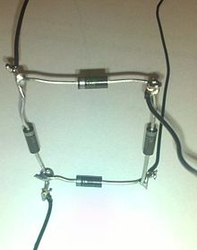
Fig. 4.16 Diode Bridge
A handmade Diode Bridge. The thick silver bar on the diodes indicates the cathode side of the diode.
A diode bridge is an arrangement of four (or more) diodes in a bridge circuit configuration that provides the same polarity of output for either polarity of input. When used in its most common application, for conversion of an alternating current (AC) input into direct current a (DC) output, it is known as abridge rectifier. A bridge rectifier provides full-wave rectification from a two-wire AC input, resulting in lower cost and weight as compared to a rectifier with a 3-wire input from a transformer with a center-tapped secondary winding.
The essential feature of a diode bridge is that the polarity of the output is the same regardless of the polarity at the input. The diode bridge circuit is also known as the Graetz circuit after its inventor, physicist Leo Graetz.

Basic operation
According to the conventional model of current flow originally established by Benjamin Franklin and still followed by most engineers today, current is assumed to flow through electrical conductors from the positive to the negative pole. In actuality, free electrons in a conductor nearly always flow from the negative to the positive pole. In the vast majority of applications, however, the actual direction of current flow is irrelevant. Therefore, in the discussion below the conventional model is retained.
In the diagrams below, when the input connected to the left corner of the diamond is positive, and the input connected to the right corner is negative, current flows from the upper supply terminal to the right along the red (positive) path to the output, and returns to the lower supply terminal via the blue (negative) path.
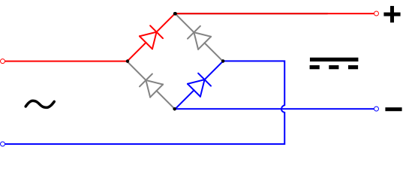
Fig.4.17 Bridge Circuit Configuration
When the input connected to the left corner is negative, and the input connected to the right corner is positive, current flows from the lower supply terminal to the right along the red (positive) path to the output, and returns to the upper supply terminal via the blue (negative) path.
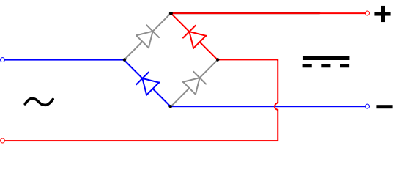

In each case, the upper right output remains positive and lower right output negative. Since this is true whether the input is AC or DC, this circuit not only produces a DC output from an AC input, it can also provide what is sometimes called "reverse polarity protection". That is, it permits normal functioning of DC-powered equipment when batteries have been installed backwards, or when the leads (wires) from a DC power source have been reversed, and protects the equipment from potential damage caused by reverse polarity.
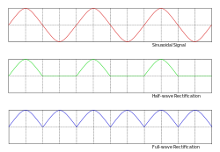
Fig. 4.18 AC, half-wave and full wave rectified signals
Prior to the availability of integrated circuits, a bridge rectifier was constructed from "discrete components", i.e., separate diodes. Since about 1950, a single four-terminal component containing the four diodes connected in a bridge configuration became a standard commercial component and is now available with various voltage and current ratings.

Output smoothing
For many applications, especially with single phase AC where the full-wave bridge serves to convert an AC input into a DC output, the addition of a capacitor may be desired because the bridge alone supplies an output of pulsed DC .
The function of this capacitor, known as a reservoir capacitor (or smoothing capacitor) is to lessen the variation in (or 'smooth') the rectified AC output voltage waveform from the bridge. There is still some variation, known as "ripple". One explanation of 'smoothing' is that the capacitor provides a low impedance path to the AC component of the output, reducing the AC voltage across, and AC current through, the resistive load.
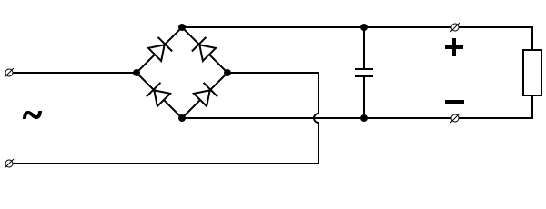
Fig. 4.19 Bridge Circuit Configuration with capacitor
In less technical terms, any drop in the output voltage and current of the bridge tends to be cancelled by loss of charge in the capacitor. This charge flows out as additional current through the load. Thus the change of load current and voltage is reduced relative to what would occur without the capacitor. Increases of voltage correspondingly store excess charge in the capacitor, thus moderating the change in output voltage / current.
The simplified circuit shown has a well-deserved reputation for being dangerous, because, in some applications, the capacitor can retain a lethal charge after the AC power source is removed. If supplying a dangerous voltage, a practical circuit should include a reliable way to discharge the capacitor safely. If the normal load cannot be guaranteed to perform this function, perhaps because it can be disconnected, the circuit should include a bleeder resistor connected as close as practical across the capacitor. This resistor should consume a current large enough to discharge the capacitor in a reasonable time, but small enough to minimize unnecessary power waste.
The capacitor and the load resistance have a typical time constant τ = RC where C and R are the capacitance and load resistance respectively. As long as the load resistor is large enough so that this time constant is much longer than the time of one ripple cycle, the above configuration will produce a smoothed DC voltage across the load.
When the capacitor is connected directly to the bridge, as shown, current flows in only a small portion of each cycle, which may be undesirable. The transformer and bridge diodes must be sized to withstand the current surge that occurs when the power is turned on at the peak of the AC voltage and the capacitor is fully discharged. Sometimes a small series resistor is included before the capacitor to limit this current, though in most applications the power supply transformer's resistance is already sufficient. Adding a resistor, or better yet, an inductor, between the bridge and capacitor can ensure that current is drawn over a large portion of each cycle and a large current surge does not occur.
In older times, this crude power supply was often followed by passive filters (capacitors plus resistors and inductors) to reduce the ripple further. When an inductor is used this way it is often called a choke. The choke tends to keep the current (rather than the voltage) more constant. Although the inductor gives the best performance, usually the resistor is chosen for cost reasons.
Nowadays with the wide availability of voltage-regulator chips, passive filters are less commonly used. The chips can compensate for changes in input voltage and load current, which the passive filter does not, and pretty much eliminate ripple. Some of these chips have fairly impressive power handling; in case this is not sufficient, they can be combined with a power transistor.
The idealized waveforms shown above are seen for both voltage and current when the load on the bridge is resistive. When the load includes a smoothing capacitor, both the voltage and the current waveforms will be greatly changed. While the voltage is smoothed, as described above, current will flow through the bridge only during the time when the input voltage is greater than the capacitor voltage. For example, if the load draws an average current of n Amps, and the diodes conduct for 10% of the time, the average diode current during conduction must be 10n Amps. This non-sinusoidal current leads to harmonic distortion and a poor power factor in the AC supply.

Generator Specifications-
Number of magnets = 16 pairs
Light weight aluminium construction
Length of shaft = 240 mm
Number of slots = 31
Type of magnets used – Rare earth magnet ( Iron-Neodymium-Boron)
Number of coils – 2

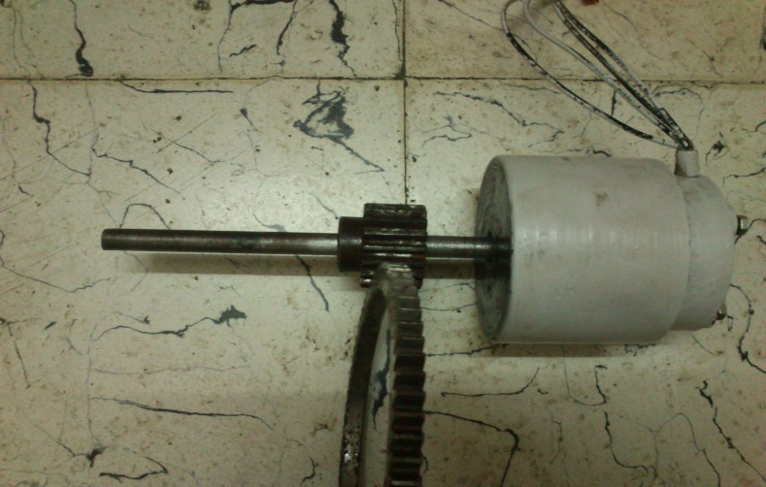
Fig. 4.20 Generator

4.3.4 SPRINGS
It is defined as an elastic body whose function is to distort when loaded and to recover its original shape when the load is removed. It cushions, absorbs or controls energy either due to shocks or due to vibrations.

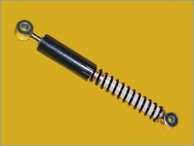
Fig. 4.21 Spring

Spring Specifications-
Total length = 22.5 cm
Pitch = 11.3 mm
Outer Diameter = 27.1 mm
Inner Diameter = 19.7 mm
Coil Diameter = 4 mm
Number of Turns = 22

4.3.5 BEARINGS
It is a machine element, which supports another machinery. It permits relative motion between the contacting surfaces while carrying the loads. They reduce the friction and transmit the motion effectively.

Bearing Specifications
Inner Diameter = 15 mm
Outer Diameter = 35 mm
Width = 8 mm
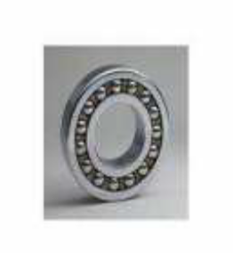
Fig. 4.22 Bearing

4.3.6 Shaft

4.3.7 Hump
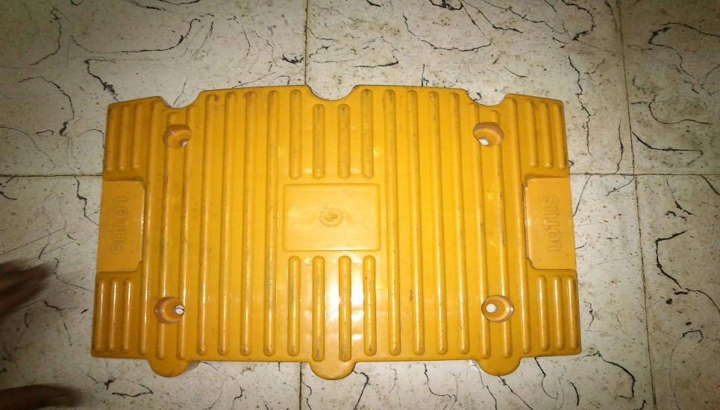
Fig. 4.23 Hump
Hump Specifications
Dimensions – 250 mm x 350 mm
Height – 50 mm at mid point
Material - Plastic

CHAPTER 5

Design And Calculations

The various machine elements used in the construction of power hump are
- RACK AND PINION
- SPUR GEAR
- BEARINGS
- SHAFT
- SPRING
- GENERATOR

RACK AND PINION:
Its primary function is to convert translatory motion into rotary motion. It must have higher strength, rigidity and resistance to shock load and less wear and tear.

Rack and Pinion Calculations
Module = Pitch Circle Diameter/ Number of teeth = 36/18 = 2 mm
Pitch Circle Radius(r) = 36/2 = 18 mm
Addendum(a) = module = 2 mm
Addendum Circle Radius (ra) = r + addendum = 18 + 2 = 20mm
Pressure angle of pinion (Φ) = 14.5° involute
Length of path of contact = (a/sin Φ) + { [ra^2 – (r sin Φ)^2]} ^0.5 - r sin Φ = 13.29 mm
Length of arc of contact = Length of path of contact / sin Φ = 13.75 mm
Minimum number of teeth in contact = Length of arc of contact / πm = 2
Angle turned by the pinion = Length of arc of contact x 360 / 2πra = 39.39°
Minimum Length of rack = 2πra = 125.66 mm

SPUR GEAR:
It is a positive power transmission device with definite velocity ratio. In volute teeth profile is preferred for adjusting some linear misalignment. It should have high wear and tear, shock-absorbing capacity.

Gear Specifications
• Outside Diameter (Do) = 155 mm
• Number of Teeth (N) = 76
• Pitch Circle Diameter (D) = Do /(1+2/N) = 155/ (1+2/76) = 151 mm
• Module = D/N = 151/ 76 =2 mm
• Pressure angle of gear (Φ) = 14.5°
• Diametral Pitch (P) = N/D = 76/151 = 0.5 mm
• Addendum (a) = 1/P = 1/0.5 = 2 mm
• Dedendum (b) = 1.157/P = 1.157/0.5 =2.31 mm
• Tooth Thickness = 1.5708/ P = 1.5708 / 0.5 =3.14 mm
• Whole Depth = 2.157/P = 2.157/0.5 = 4.314 mm
• Clearance = 0.157/ P = 0.157/0.5 = 0.314 mm
• Center Distance = (N1 + N2)/ (2*P) = (76 + 18 )/ (2* 0.5) = 94 mm
• Working Depth = 2/P = 2/0.5 = 4 mm
• Addendum Circle Diameter = D + 2m =151 + 2(1.98) = 154.96 mm
• Dedendum Circle Diameter = D – 2.5m = 151 -2.5(1.98) = 146.05 mm

Pinion Specifications
• Outside Diameter ( Do ) = 40 mm
• Number of Teeth (N) = 18
• Pitch Circle Diameter (D) = Do / (1+2/N) = 40/ (1+2/18) = 36 mm
• Module = D/N = 36/ 18 =2 mm
• Pressure angle of pinion (Φ) = 14.5°
• Diametral Pitch (P) = N/D = 18/36 = 0.5 mm
• Addendum (a) = 1/P = 1/0.5 = 2 mm
• Dedendum (b) = 1.157/P = 1.157/0.5 =2.31 mm
• Tooth Thickness = 1.5708/ P = 1.5708 / 0.5 =3.14 mm
• Whole Depth = 2.157/P = 2.157/0.5 = 4.314 mm
• Clearance = 0.157/ P = 0.157/0.5 = 0.314 mm
• Center Distance = (N1 + N2)/ (2*P) = (76 + 18 )/ (2* 0.5) = 94 mm
• Working Depth = 2/P = 2/0.5 = 4 mm
• Addendum Circle Diameter = D + 2m =36 + 2(2) = 40 mm
• Dedendum Circle Diameter = D – 2.5m = 36 -2.5(2) = 31 mm

Design of Gears
(1)Power to be transmitted from 1st shaft to 2nd shaft (P) = 0.18 KW
Number of teeth on gear (z₂) = 76
Number of teeth on pinion (z₁) = 18
Speed of gear (n₂) = 70 rpm
Speed of pinion (n₁) = 280 rpm
Velocity Ratio (i) = n₁/n₂ = Z₂/Z₁ = 4 ………………. (6.1)

1) Identify the weaker member
Lewis form factor for 14.5° involute y = 0.124 – 0.684/z ……………….. (6.2)
Lewis form factor for pinion y₁ = 0.124 – 0.684/ z₁ = 0.124 - 0.684/18 = 0.086
Lewis form factor for gear y₂ = 0.124 – 0.684/ z₂ = 0.124 - 0.684/76 = 0.115
Allowable stress for pinion and gear σ_{o}= 137 MPa
σ_{o} y₁= (137) (0.086) = 11.78
σ_{o}y₂= (137) (0.115) =15.75
Since σ_{o} y₁ <σ_{o}y₂ , pinion is weaker. Therefore design should be based on pinion.

2) Design
a) Tangential tooth load
F_{t} = 9550 x 1000 x P x C_{s} / n₁ r₁ ………………….. (6.3)
= 9550 x 1000 x 0.18 x 1.5 / 280 x 9m
= 1023.21 / m ............................(i)

b) Lewis Equation for tangential tooth load
F_{t} = σ_{o}b y p K_{v} ……………….. (6.4)
Face Width (b) = 10m
Circular Pitch (p) = πm
F_{t} = (137) (10m) (0.086) (πm) K_{v}
= 369.95 m² K_{v} …………………(ii)

Mean pitch line velocity of weaker member v_{m}= π d₁ n₁ / 60000 ……………… (6.5)
= π x m x 18 x 280 / 60000
= 0.263 m
Equating equations (i) and (ii)
369.95 m² K_{v} = 1023.21 / m
m³K_{v}= 2.765 ………………….(iii)
Trial 1 :
Select module m = 1mm
v_{m}= 0.263 x 1 = 0.263 m/sec
Velocity Factor K_{v}= 3 / 3 + v_{m}= 3 / 3 + 0.263 = 0.919 [v_{m}< 7.5 m/sec] …… (6.6)
From equation (iii)
(1)³ (0.919) ≥2.765
0.919 < 2.765

Trial 2 :
Select module m = 2 mm
v_{m}= 0.263 x 2 = 0.526 m/sec
Velocity Factor K_{v}= 3 / 3 + v_{m}= 3 / 3 + 0.526 = 0.85 [v_{m}< 7.5 m/sec]
From equation (iii)
(2)³ (0.85) ≥2.765
6.8 > 2.765
... Module m = 2 mm

c) Check for the stress
Allowable Stress σ_{all}= (σ_{o1} K_{v})_{all} = (137) (0.85) = 116.45 N/mm²
Induced Stress σ_{ind}= (σ_{o1} K_{v})_{ind} = F_{t} / b y₁ p
= [1023.21 / 2] / (10 x 2) (0.086) (π x 2)
= 47.33 N/mm²
Since (σ_{o1} K_{v})_{ind}< (σ_{o1} K_{v})_{all} , the design is safe.

(2)Power to be transmitted from 2nd shaft to 3rd shaft (P) = 1.22 KW
Number of teeth on gear (z₂) = 76
Number of teeth on pinion (z₁) = 18
Speed of gear (n₂) = 280 rpm
Speed of pinion (n₁) = 1120 rpm
Velocity Ratio (i) = n₁/n₂ = Z₂/Z₁ = 4

1) Identify the weaker member
Lewis form factor for 14.5° involute y = 0.124 – 0.684/z
Lewis form factor for pinion y₁ = 0.124 – 0.684/ z₁ = 0.124 - 0.684/18 = 0.086
Lewis form factor for gear y₂ = 0.124 – 0.684/ z₂ = 0.124 - 0.684/76 = 0.115
Allowable stress for pinion and gear σ_{o}= 137 MPa
σ_{o} y₁= (137) (0.086) = 11.78
σ_{o}y₂= (137) (0.115) =15.75
Since σ_{o} y₁ <σ_{o}y₂ , pinion is weaker. Therefore design should be based on pinion.

2) Design
a) Tangential tooth load
F_{t} = 9550 x 1000 x P x C_{s} / n₁ r₁
= 9550 x 1000 x 1.22 x 1.5 / 1120 x 18m
= 866.88 / m ...........................(i)

b) Lewis Equation for tangential tooth load
F_{t} = σ_{o}b y p K_{v}
Face Width (b) = 10m
Circular Pitch (p) = πm
F_{t} = (137) (10m) (0.086) (πm) K_{v}
= 370.14m² K_{v} …………………(ii)

Mean pitch line velocity of weaker member v_{m}= π d₁ n₁ / 60000
= π x m x 18 x 1120 / 60000
= 1.055m
Equating equations (i) and (ii)
370.14m² K_{v} = 866.88 / m
m³K_{v}= 2.34 ………………….(iii)
Trial 1 :
Select module m = 1 mm
v_{m}= 1.055 x 1 = 1.055 m/sec
Velocity Factor K_{v}= 3 / 3 + v_{m}= 3 / 3 + 1.055 = 0.739 [v_{m}< 7.5 m/sec]
From equation (iii)
(1)³ (0.739) ≥2.34
0.739< 2.34

Trial 2 :
Select module m = 2 mm
v_{m}= 1.055 x 2 = 2.11 m/sec
Velocity Factor K_{v}= 3 / 3 + v_{m}= 3 / 3 + 2.11 = 0.58 [v_{m}< 7.5 m/sec]
From equation (iii)
(2)³ (0.58) ≥2.34
4.64> 2.34
... Module m = 2 mm

c) Check for the stress
Allowable Stress σ_{all}= (σ_{o1} K_{v})_{all} = (137) (0.58) = 79.46 N/mm²
Induced Stress σ_{ind}= (σ_{o1} K_{v})_{ind} = F_{t} / b y₁ p
= [866.88 / 2] / (10 x 2) (0.086) (π x 2)
= 40.1 N/mm²
Since (σ_{o1} K_{v})_{ind}< (σ_{o1} K_{v})_{all} , the design is safe.

SHAFTS:
It is a rotating element, which is used to transmit power from one place to another place. It supports the rotating elements like gears and flywheels. It must have high torsional rigidity and lateral rigidity.

Shear Stress in the shaft
It is calculated using the torsion equation-
T/J = τ/ r ………………….. (6.7)
Where, T – Torque Transmitted (N-mm)
J – Polar Moment of Inertia (mm⁴)
τ - Shear stress (N/mm²)
r – Radius of the shaft (mm)

T/ (πd^4/32) = τ/(d/2)
Torque Transmitted (T) = Force x Radius of shaft
= 150 x 9.81 x 19
= 27958.5N-mm

27958.5/[π(19^4)/32] = τ / (38/2)
Shear stress (τ) = 41.51 N/mm²
[All the important formulae and values have been taken from Machine Design Data Handbook vol.1 and 2 by Dr. K. Lingaiah]

Chapter 6
Fabrication

Fabrication was the most important and time consuming part of our project. We put together the model using all the knowledge and skills acquired during the 4 years of our engineering course. We started with the base which is the box made up of 5 individual pieces of plywood held in place together with the help of L-clamps, nuts and bolts.
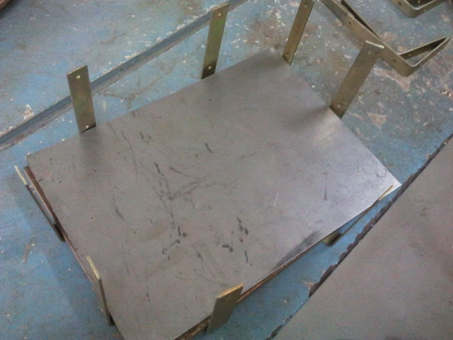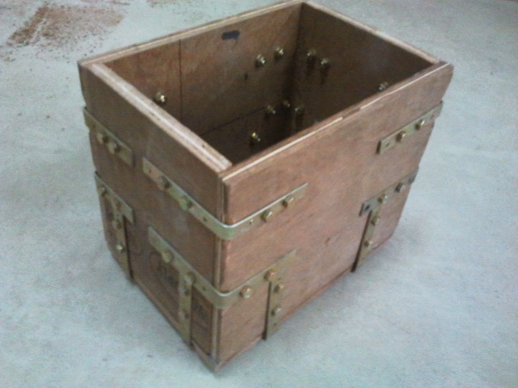
Fig. 6.1 Wooden Box
The bearing supports were fabricated out of 2 inch square hard wood blocks. Four such supports were prepared. Holes were drilled into the supports and the diameter was increased by boring to house the bearings. Then the bearings were hydraulically press fit into the holes machined.

Fig. 6.2 Making of Bearing Supports out of wood

The shafts were machined to the required dimensions out of a brite rod.
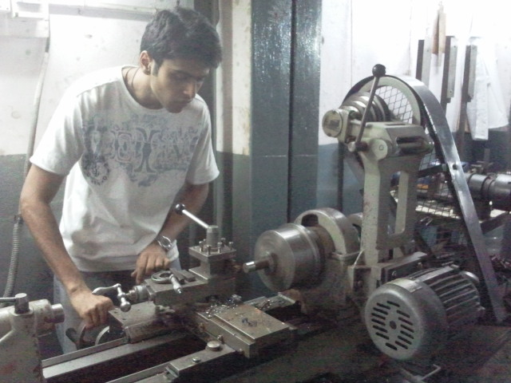
Fig. 6.3 Machining of shafts
The gears were then hydraulically press fit onto the shaft. This assembly of shafts was then mounted on the bearing supports. The bearing supports along with the shaft and gears was positioned accurately and fixed inside the wooden box.
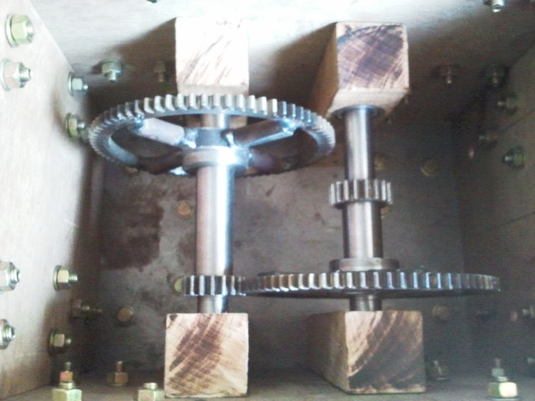
Fig. 6.4 Shaft and Gear Assembly
The brackets to hold the shock absorber were fabricated and mounted firmly to the box.
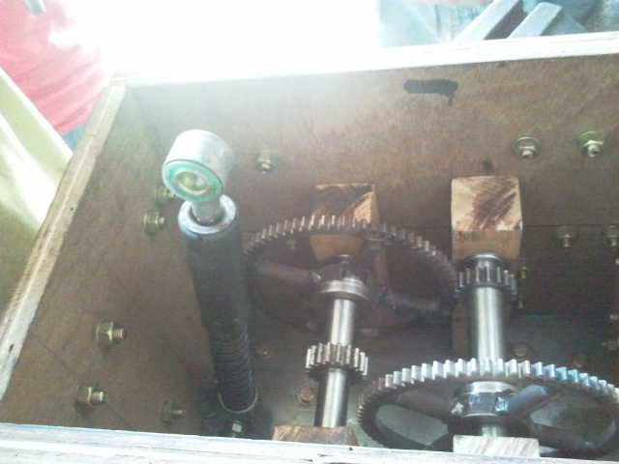
Fig. 6.5 Mounting of Shock Absorber
The plastic hump was fixed on the box by welding the hinges to the steel plate on the back of the hump and by using nuts and bolts to fix it to the wooden box. The mountings for the rack and the upper end of shock absorber were welded. All the welding involved in the project was carried out by a professional.
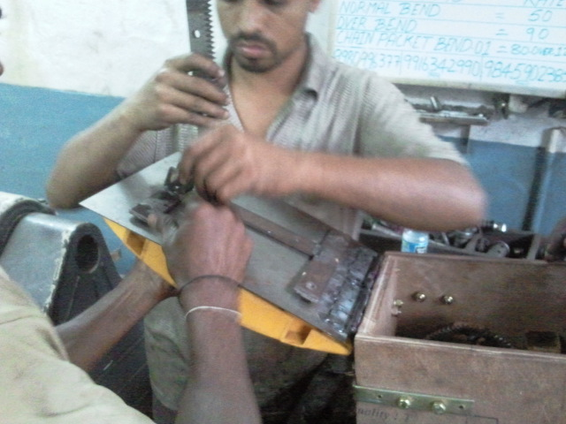
Fig. 6.6 Rack attachment to the hump
The generator shaft was machined out of brite rod to at most dimensional accuracy. And the aluminium housing having the magnets was pressed fit onto the shaft using a hydraulic press.

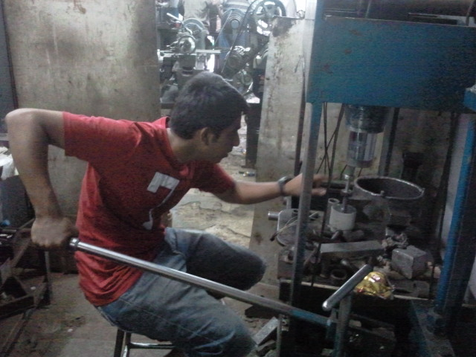
Fig. 6.7 Hydraulic Press

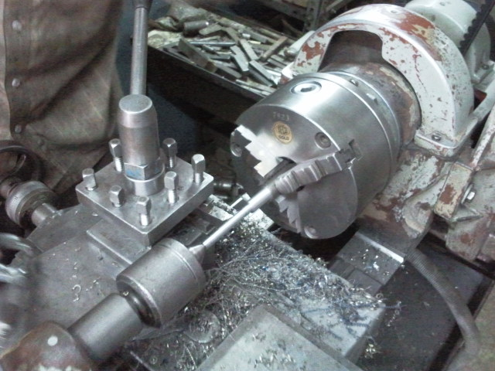
Fig. 6.8 Machining of generator shaft
The mountings for the generation were fabricated out of mild steel plates. The bearing support for the generator shaft was also fabricated out of mild steel plates. The generator was then mounted to the box using nuts and bolts.
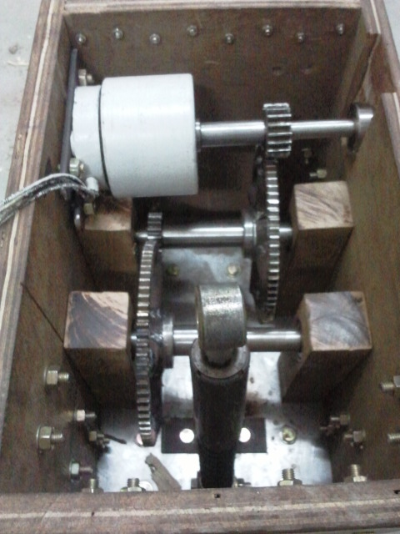
Fig. 6.9 Complete assembly of the parts

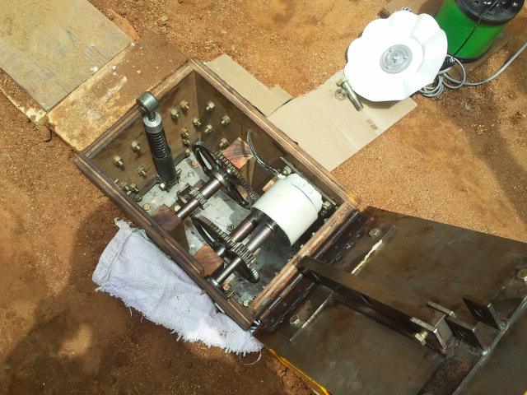
Fig. 6.10 Final Assembly of the project

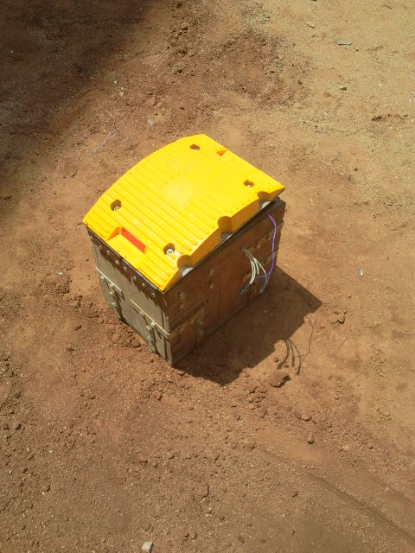
Fig. 6.11 Power Hump

Chapter 7
Future Scope of Power Humps

Future work would consist of a redesign of this model to see exactly how much data we may be missing with the assumption that we made with low price, weight and capacity. Despite all the assumptions, we still have realized that this product can be very marketable and that the demand is extremely large which means this is a viable design that will yield a high return on an investment.
- Such speed breakers can be designed for heavy vehicles, thus increasing input torque and ultimately output of generator.
- More suitable and compact mechanisms to enhance efficiency.
- Various government departments can take up an initiative to implement these power humps on a large scale.
- These can be mainly used at toll booths , approaching traffic signals , highways where vehicles move 24 x 7 etc…
- This has a huge scope everywhere provides the resources are channelled well.

Chapter 7
Results and conclusion
Energy is an important input to sustain industrial growth and standard of living of a country and can be directly related to the per-capita energy consumption. The conventional sources of energy and depleting very fast and by the turn of the century man will have to depend on non-conventional sources for power generation. Various types of non-conventional sources are solar energy, wind energy, biogas etc. Now by using these speed breakers, we can generate electricity without any external sources.
This day, vehicle traffic is a major issue in most big cities. This can be used to our advantage by installing these speed breakers in heavy traffic roads and toll booths we can generate electricity almost continuously by using the weight of the vehicles to produce mechanical power in the shafts by using the rack and pinion mechanism. As this method does not require any external power source and the traffic never reduces, these speed breakers are more reliable and have a greater life span.
Advantages
- Economical and easy to install
- It is eco-friendly
- Maintenance cost is low
- Will solve some of the electricity problems of the world
- This can be implemented on heavy traffic roads and toll booths and can be used to power the street lights
- It can be a solution the electricity shortage in most villages
Disadvantages
- The mechanism has to be checked often
- The gears might rust during the rainy season or in very humid environment
- It will not work if the weight of the vehicle is below 200 kilograms
Result
Load = 300Kg (weight of the vehicle + weight of the rider)
Speed of the vehicle (km/hr) | Voltage generated (volts)
5 | 60
10 | 54
15 | 49

REFERENCES

- Dr Anders Brandt & MSc Johan Granlund, Swedish Road Administration (2008). "Bus Drivers’ Exposure to Mechanical Shocks Due To Speed Bumps". Society for Experimental Mechanics, IMAC XXVI Conference and Exposition on Structural Dynamics.
- Mukherjee.DChakrabarti.S, 2005, Fundamentals of renewable energy systems, New Age international limited publishers, New Delhi.
- Power System Dynamics and Control’, K R Padiyar, Interline Publishers Bangalore.
A study paper on power hump by N. Rama Krishna 01010-M-039 A.A.N.M&V.V.R.S.R
Polytechnic Gudlavalleru-521356
- http://www.docstoc.com/docs/20078694/POWER-HUMP
- http://www.iitg.ac.in
- http://www.scribd.com/doc/29409954/POWER-GENERATION-USING-SPEED-BREAKERS, retrieved on 22-02-2012
- Miller G wayne (2000-0707) “Fortune’s clulctrev”a newly perfect summery (Providence Journal)
- A text book of Strength Of Materials – R.K Rajput, S.Chand publications
- A text book of Machine Design - R.S. Khurmi and J.K. Gupta, S.Chand publications

