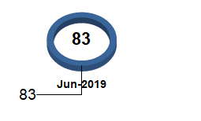

Add database field inside doughnut

Goal 90