My test files in the order they are read in:

The error reports being produced (first file name should end with *test_extra)

Values inside error report of first file (contents of report are correct but file name should end with *test_extra)

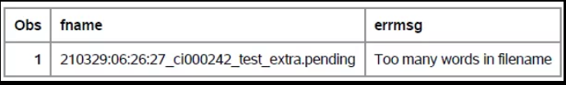

Values inside error report of second file -- fname should be 210329:10:58:19_ci6652_test00.pending12 errmsg should say Missing leading zeroes in filename CI

